Name Surname, Times New Roman, 11 pt, bold

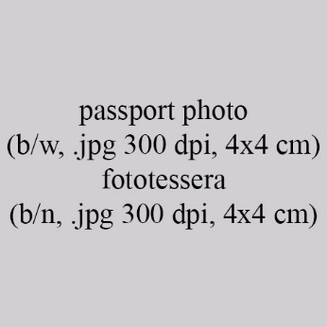

Text (English language), max 1,000 characters including spaces, Times New Roman, 11 pt, regular.

Testo (Italian or the author’s native language), max 1.000 battute spazi inclusi, Times New Roman, 11 pt, normale.

